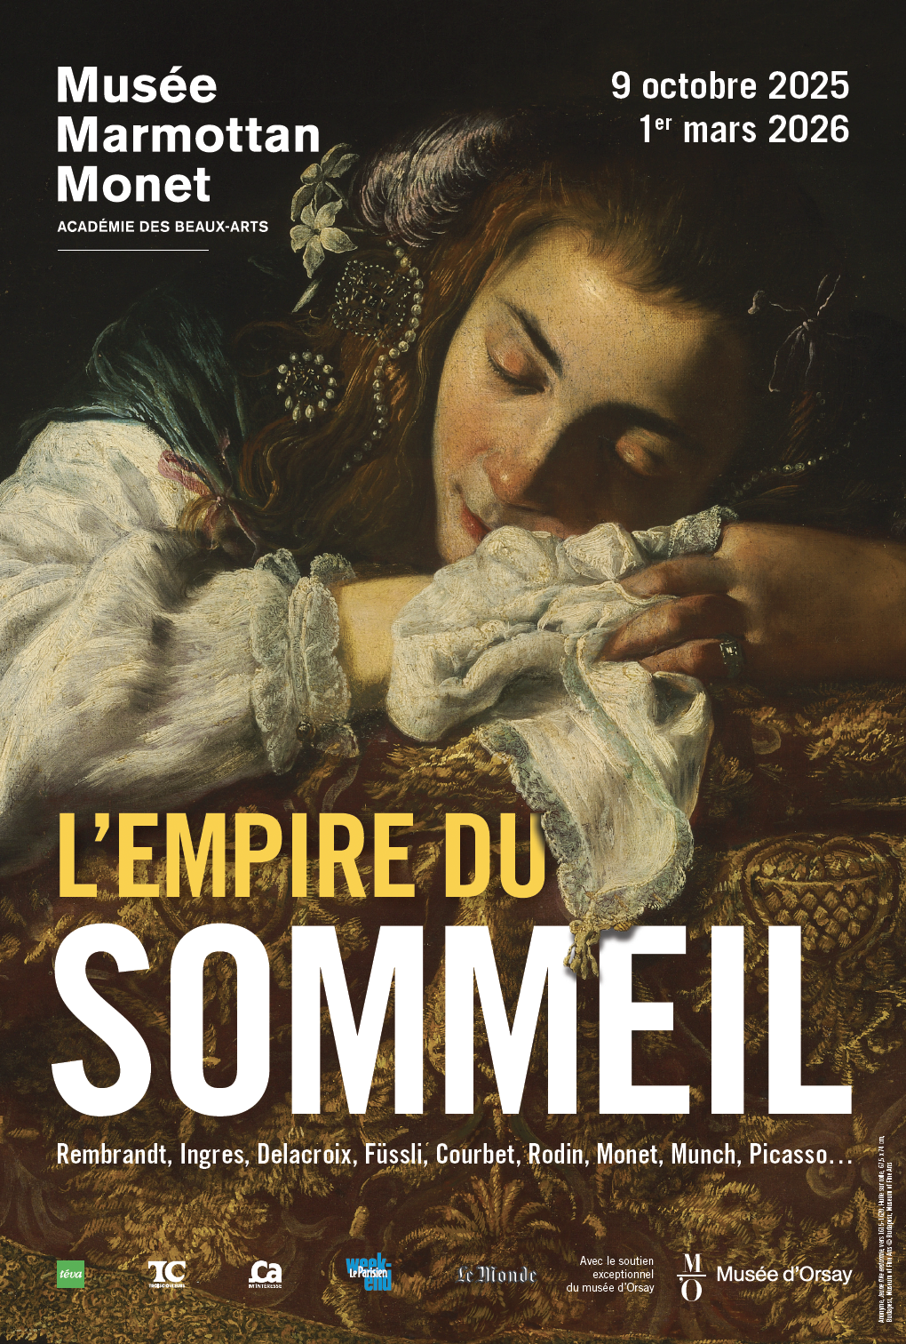

TABLE OF CONTENTS

I - Foreword

II - Press Release

III - Exhibition Tour

IV - About the Exhibition

V - Curators - Scenography

VI - Press visuals

VII - 2026 Program

VIII - Practical Informations

Translated from French
This is an unofficial translation. In case of discrepancies, the French version shall prevail.
I - Foreword

They say sleep occupies one-third of our existence, and it has always inspired artists, writers, musicians, and philosophers. However, this exhibition appears to be the first in France to address this phenomenon, at least in its formal, artistic representation. This is a curious absence that we propose to rectify, as the mythology of sleep and dreams has always occupied our thoughts, since Antiquity. Think of Endymion, lover of Selene, goddess of the Moon, represented countless times up to Girodet or Watts, but also the biblical and evangelical accounts: Noah's drunkenness, Job's insomnia, John asleep during the Last Supper, the apostles dozing in the Garden of Olives, or the Dormition of the Virgin, that strange state of suspension between sleep and eternal life.
Hypnos, Thanatos, Eros, a beauty of sleep but also an ambiguity is revealed in all these mythical figures. Beyond the real appearance of the sleeping person, there is, invisibly, the dream... Behind the dozing person, the tumult and enigma of the dream world, the parade of dreams, but also the cradle of nightmares. Consider Le Songe de Poliphile (The Dream of Poliphilus), a link between the ancient world and the Renaissance, The Sleep of Reason Produces Monsters, Füssli's incubi, Courbet's Somnambule (The Sleepwalker), the extravagant adventure of The Glove in Klinger's engravings, and even further, Munch's Noctambule (Night Wanderer) or the visionary dreams of Little Nemo in Slumberland.
The exhibition presented here attempts to unveil these mysteries in eight chapters, from "Sweet Sleep" to "The Gates of Dreams" and "Troubled Sleep". It aims both to reveal the representations of this very particular, well-hidden state and to open the endless labyrinth of the world of dreams, where artists and poets give free rein to their creative imagination. Every exhibition is a construction, and Laura Bossi is its architect. As a neurologist and science historian, she has, with sensitivity and erudition, built this tribute to poetry and the imagination. She was assisted in this adventure by Sylvie Carlier, the museum's director of collections, and by Anne-Sophie Luyton, a conservation officer. We extend our warmest thanks to all three of them, as well as to all the teams at the Musée Marmottan Monet.
Our deepest gratitude goes to the lenders, collectors, and heads of French and international museums who have enabled this event to achieve all the stature it deserves, by materializing what had until then been only dreams through the works they have lent. Finally, we thank the catalog contributors who, through their writings and reflections, provide an essential complement to the exhibition.

Érik Desmazières
Member of the Institut
Director of the Musée Marmottan Monet

II – Press Release
Scientific Curator: Laura BOSSI, neurologist, science historian, exhibition curator
Associate Curator: Sylvie CARLIER, director of collections at the Musée Marmottan Monet, chief heritage curator
Assisted by: Anne-Sophie LUYTON, conservation officer at the Musée Marmottan Monet
From October 9, 2025, to March 1, 2026, the Musée Marmottan Monet presents the exhibition
"L’Empire du sommeil" (The Empire of Sleep), which, for the first time in France, explores the representations of this mysterious state that occupies one-third of our lives and has nourished creation since Antiquity.
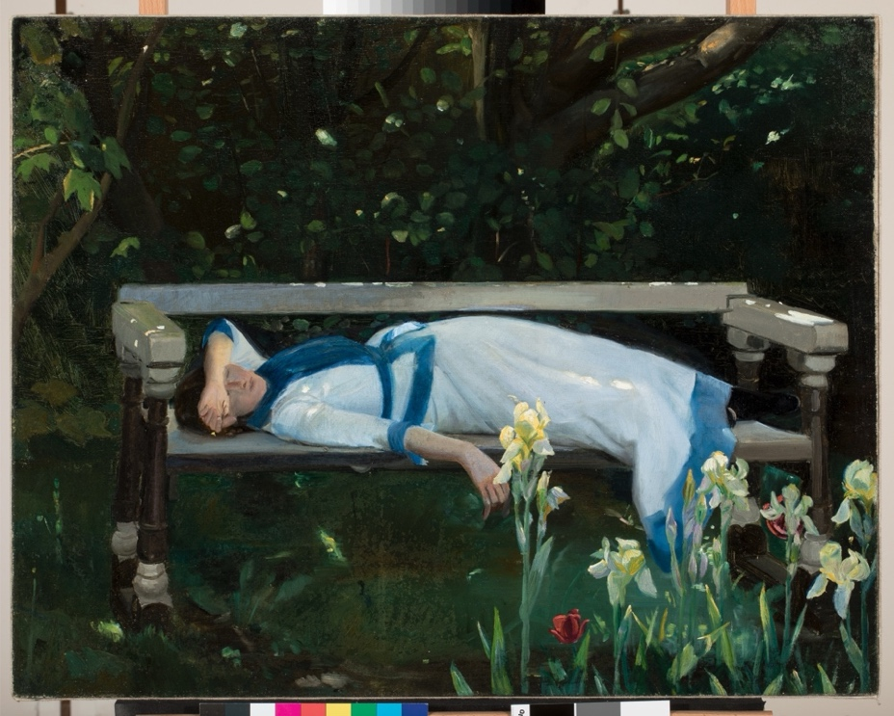
Michael Ancher (1849 1927), La Sieste [Middagshvil], 1890, Huile sur toile, 62 x 79 cm, Skagen, Art Museums of Skagen
© Art Museums of Skagen
Curated by Laura Bossi, a neurologist and science historian, and Sylvie Carlier, the museum's director of collections, the exhibition shows the breadth and variety of iconographic themes represented by artists throughout the ages. In keeping with the spirit of the museum's collections, it focuses on the "long nineteenth century," from the Enlightenment to the Great War, also featuring a selection of ancient or contemporary works that shed light on the subject's fascination and its surprising persistence, beyond philosophical and scientific developments.
One hundred and thirty works have been brought together for the occasion—paintings, sculptures, graphic works, objects, and scientific documents—from private collections and major French and international institutions (Musée d’Orsay, Musée du Louvre, Musée national d’Art moderne, Petit Palais-Musée des beaux-arts de la Ville de Paris, Musée des Beaux-arts de Montréal, Galerie Nationale de Prague, Palazzo Pitti-Galleria d’Arte Moderna de Florence, Museo Nacional Centro de Arte Reina Sofía de Madrid, etc.).
The exhibition tour, consisting of eight thematic sections, offers both an aesthetic and scholarly journey through the faces of sleep and its disturbances.

III – Exhibition Tour

Doux sommeil, bonheur pur (Sweet sleep, pure happiness)

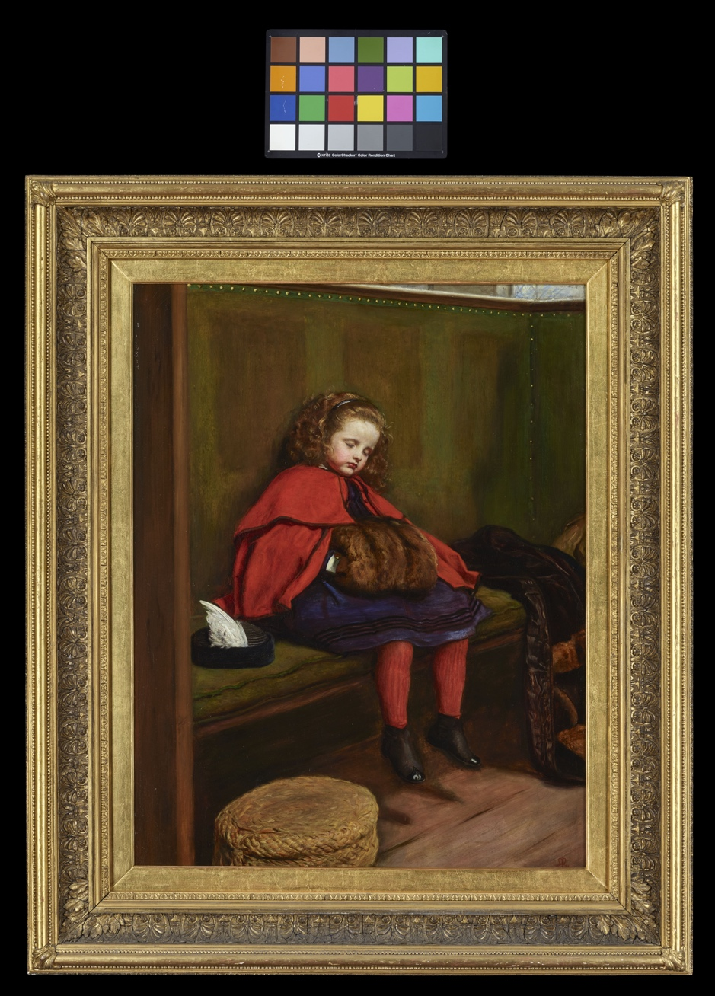
John Everett Millais, Mon deuxième sermon [My Second Sermon], 1864, Huile sur toile, 97 x 72 cm
Londres, Guildhall Art Gallery © Guildhall Art Gallery, City of London

We all sleep, even insomniacs. Sleep, this sweet necessity that occupies a third of our lives, is essential to us and provides us with great happiness. It brings rest and the forgetting of the day's troubles. This mysterious state into which we "fall" has nourished creation for millennia. Countless artists have left us portraits of their loved ones—parents, spouses, lovers—or their sleeping models, in the middle of the night or, more often, during the day, for a nap. Perhaps it's the sleep of the innocent—newborns, children, family pets, cats, dogs...—that best expresses the surrender to the happiness of unconsciousness. But sleep also shows an ambiguous side; it can evoke death, vulnerability, and the loss of self; it requires us to abandon vigilance, to accept oblivion, to no longer watch or monitor...
The exhibition, for the first time in France, explores the diverse representations of sleep and its disturbances, focusing on the "long nineteenth century," from the Enlightenment to the Great War. Older works as well as works from the 20th century are included to show the extraordinary richness of the subject and the persistence of its iconographic themes.

Figures du sommeil dans la Bible (Figures of sleep in the Bible)

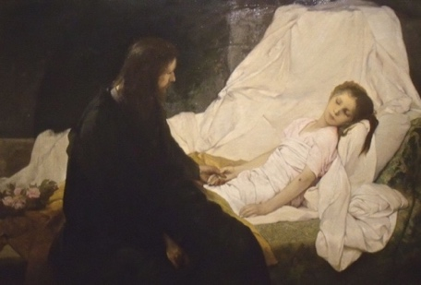
Gabriel von Max, La Résurrection de la fille de Jaïre, 1878. Huile sur toile, 123.3 x180.4 cm
Montréal, Musée des beaux-arts © MBAM, Denis Farley

To grasp the various facets of sleep, we must go back to the origins of Western culture—first the Bible and then the permanence of ancient myths revisited during the Renaissance. In Genesis, sleep belongs to the symbolism of origins: Adam is asleep during the creation of Eve. Noah reminds us of the dangers of sleep troubled by drunkenness. The Psalms and the Book of Job link insomnia to faults and torments of the soul. The sleep of the infant Jesus is often represented as an anticipation of the Passion, and the tenderness of the iconography of the Virgin watching the sleeping Child reenacts the pain of the Pietà.
Through faith in the Resurrection, death is now perceived as a sleep from which one will be awakened—the miracle of the resurrection of Jairus's daughter. In the episode of John asleep during the Last Supper, sleep expresses trust in God and joyful surrender. The Dormition of the Virgin reveals that Mary fell asleep in God.

Hypnos et Thanatos : le sommeil et la mort sont frères (Hypnos and Thanatos: sleep and death are brothers)

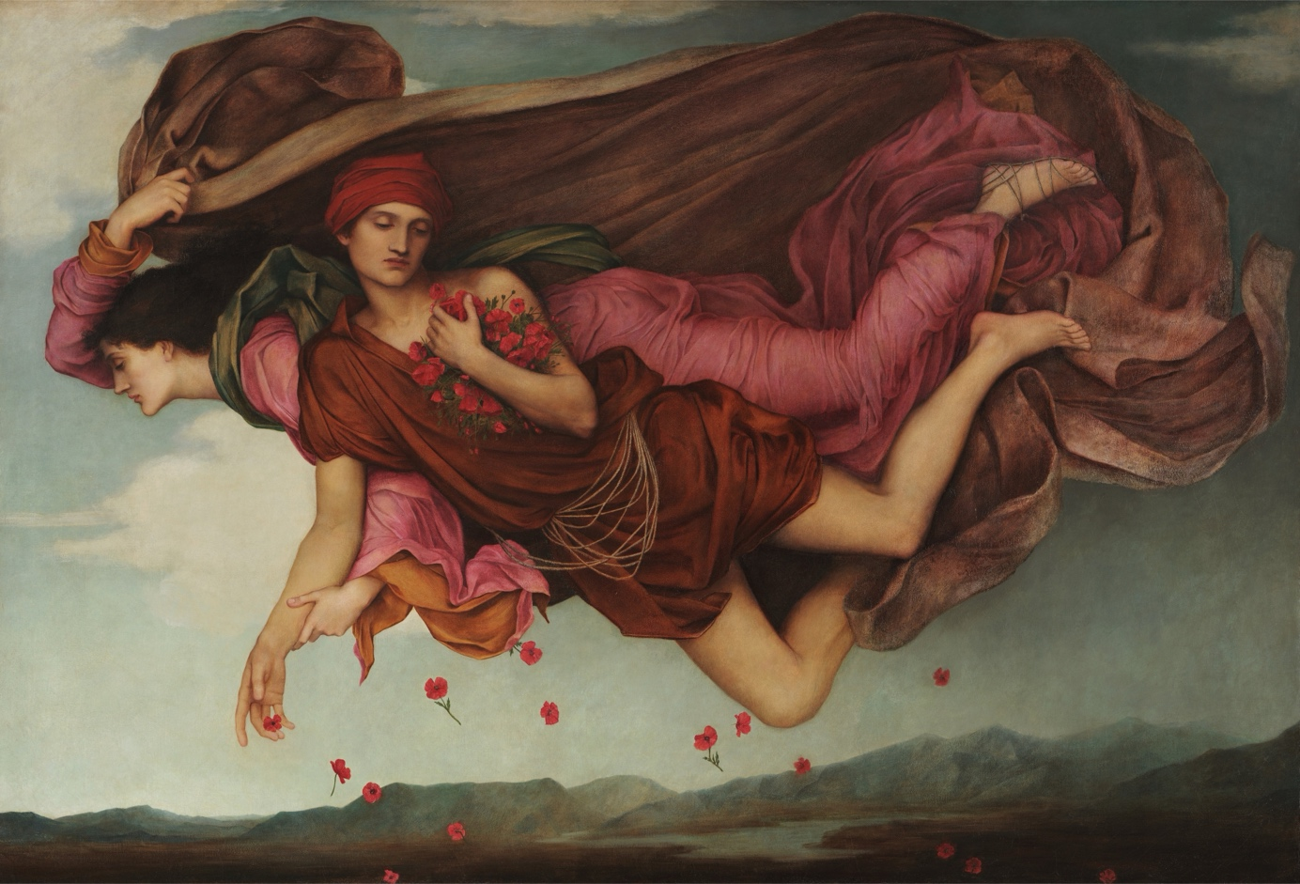
Evelyn De Morgan, Nuit et Sommeil [Night and Sleep], ​1878. Huile sur toile. 108,8 x 157,8 cm.
Barnsley, De Morgan Foundation © Trustees of the De Morgan Foundation

In Greek mythology, Night (Nyx) gives birth to Hypnos (sleep) and Thanatos (death) (Klotz). It is probably the atony, the loss of muscle strength during sleep, and the external resemblance of the two conditions that inspired the myth. Hypnos is represented as a winged young man, sometimes asleep, sometimes holding a horn filled with water from the Lethe or poppy juice, used as a hypnotic for millennia.
In the 19th century, portraits and photographs of corpses on their deathbed, seemingly asleep, adorned for remembrance, recall this closeness between eternal rest and daily sleep. Artists like Monet, and later Hodler, would even paint their wife or mistress on their deathbed.

Le sommeil érotique : Amour dévoilé et Belles endormies (Erotic sleep: Love revealed and Sleeping beauties)

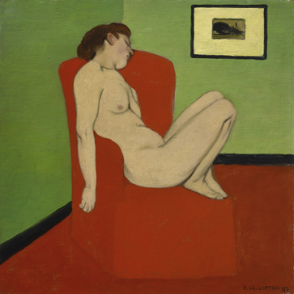
Félix Vallotton, Femme nue assise dans un fauteuil, 1897. Huile sur carton marouflé sur contre-plaqué. 28 x 27,5 cm.
Grenoble, musée de Grenoble © Musée de Grenoble - J.L Lacroix

The King of the gods, Zeus to the Greeks, Jupiter to the Romans, reveals the body of a sleeping Antiope. The sensuality of the gesture would be repeated through the centuries from Rembrandt to Picasso. Conversely, it would also be Psyche revealing the sleeping Eros, or Selene, the Moon, in love with the handsome Endymion. To see and to be seen, the erotic gaze unseals nudity, both feminine and masculine. The sleeping Venuses and nymphs of neoclassical painting become sleeping young ladies, friends surprised in their sleep after love, or young women dreaming, dozing in an armchair. Fairy tales like Sleeping Beauty naively illustrate the power of Eros, who pulls the Sleeping Beauties from their enchanted slumber, marking the passage from childhood to adulthood.

Les portes du rêve (The gates of dreams)

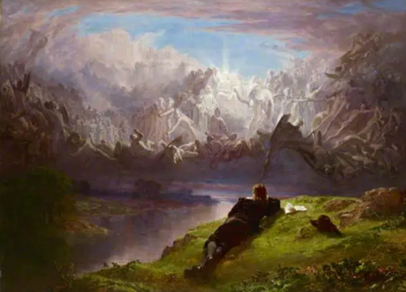
John Faed, Le Rêve du poète, 1881 – 1882. Huile sur toile. 104,7 x 142,9 cm
Edimbourg, Royal Scottish Academy of Art & Architecture Collections (RSA) © RSA Collections, Edinburgh

Since Homeric times, people have tried to interpret dreams in a prophetic sense, even though Homer, through the mouth of the wise Penelope, already warned against deceptive dreams. While modern sleep medicine is recent, it was in the 19th century that a scientific study of dreams began, with the works of Alfred Maury (1861) and Hervey de Saint Denis (1867). Freud's Traumdeutung (The Interpretation of Dreams) was published in 1899 and translated into French in 1926. The dream is no longer prophetic but reflective; it reveals nothing about our future but illuminates our past. Sleep and dreams would henceforth populate the works of the Symbolists who strove to represent inner life, such as Odilon Redon, Khnopff, Max Klinger, or Kubin.
Artists and poets would often evoke the possibility of creative sleep. Inspiration comes during the night, and the Muse imposes a return to work on the artist. In Lorenzo Lotto's Apollon endormi (Sleeping Apollo), it is once the sun god is plunged into sleep that the Muses dance.

Le sommeil troublé – quand la raison s’absente (Troubled sleep – when reason is absent)

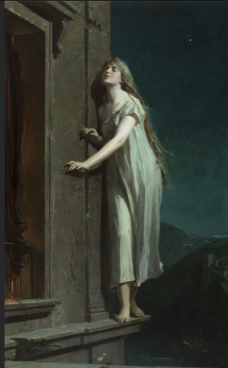
Maximilián Pirner, La Somnambule, 1878. Huile sur toile. 157 × 87 cm.
Národní galerie / National Gallery © Photo National Gallery Prague 2025

In the 18th century, Goya, Füssli, and Blake questioned the dark side of the Enlightenment to try to give form and credence to the evanescent figures of nightmares. The Romantics denounced the hold of reason by exploring what was now called the unconscious, mediumistic phenomena, madness, and sleepwalking. In the 19th century, Charcot at La Salpêtrière experimented with hypnosis on hysterical patients. Freud was fascinated by hypnosis but soon abandoned it. After the Great War, the Surrealists resumed the exploration of the nocturnal domain and used hypnosis as a "creative" process.
Nowadays, perhaps it is insomnia that troubles us the most. In industrial civilization, work rhythms, artificial light, city noise, screens, and stimulants prevent us from falling asleep. Hindered from all sides, sleep has become an object of desire that we try to regain by all means. Among the drugs we resort to for rest, opium is the oldest. The poppy is often represented as a symbol of sleep and oblivion, and by extension, of death. The Symbolists were happy to paint it. Several writers at the end of the 19th century experimented with reveries induced by laudanum and hashish; Gaetano Previati's painting shows the "cursed" atmosphere of an opium den.

Au lit ! (To bed!)

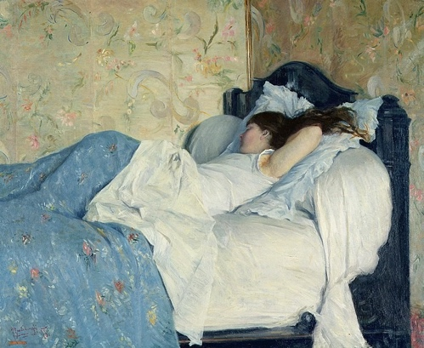

Federico Zandomeneghi, Jeune fille endormie dit aussi dit aussi Intérieur avec figure féminine endormie [Fanciulla dormiente (interno con figura femminile che dorme)]1878. Huile sur toile. 60 x 74 cm
Florence, Palazzo Pitti – Galleria d’Arte Moderna © Gabinetto Fotografico delle Gallerie degli Uffizi

The word "chambre" (room) comes to us from the Greeks (kamara), and our "bed civilization" is Roman. The bed is the main piece of furniture, even for the poor who all sleep together. In the homes of the wealthy, beds are found in reception rooms. At the end of the Middle Ages, the bedroom was established as a private space, sheltered from prying eyes. In the 19th century, Christian morality dictated conduct in the bedroom: everything had to be modest and veiled.
Warm and cozy, the bed is a refuge and a shelter. Formerly a place of birth, love, sickness, and death, it retains a metaphysical "aura," even if it is today replaced by an anonymous hospital bed. One only sleeps well in their own bed. For a child, it's in the parents' big bed that comfort is found when the fear of the dark fades. But the bed can also be a place of surrender and sensuality. An unmade bed suggests the presence of the Other, both strange and familiar, and troubles us. The bedroom is a place of intimacy, and the bed is an island that allows us to protect and nourish our dreams.

IV – About the Exhibition

Exhibition Catalog

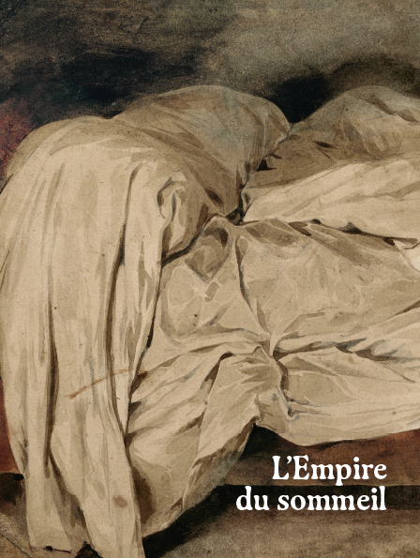

Title : L’Empire du sommeil (The Empire of Sleep)
Under the direction of: Laura Bossi, neurologist, science historian, exhibition curator

With contributions from: Ivan Alexandre, Isabelle Arnulf, Laura Bossi, Jacqueline Carroy, Jean-Baptiste Maranci, Dominique Païni

Co-published by: musée Marmottan Monet / Éditions In fine
Format : 22 x 28,5 cm — 248 pages
Price: 35 euros including tax — ISBN: 978-2-38203-237-4

V – Curators - Scenography

Scientific Curator: Laura BOSSI, neurologist, science historian, exhibition curator

Laura Bossi is a neurologist and science historian. Born in Milan, she has lived and worked in Paris since 1978. Her scientific career, dedicated mainly to research on epilepsy, neurodegenerative diseases, and neuropharmacology, has resulted in nearly 200 international publications and two works in English.
In parallel, she has published important works on the history and philosophy of science, including Histoire naturelle de l’âme (2003), Crime et folie (2011), Les frontières de la mort (2013, Prix Biguet de l’Académie française) and Ernst Haeckel et les Français (2024). She is currently completing an intellectual biography of the German scholar Ernst Haeckel, to be published by Editions Les Belles Lettres.
She has participated in numerous exhibitions exploring the links between art history, the history of ideas, and the history of science, including Mélancolie (Grand Palais, 2005; Neue Nationalgalerie, Berlin, 2005), Crime et châtiment (Musée d’Orsay, 2010), Les archives du rêve (Musée d’Orsay, 2014), Sigmund Freud, du regard à l’écoute (MAHJ, 2018), and Figures du fou(Louvre, 2024). In 2020, at the Musée d’Orsay, she was the general curator and directed the catalog for the exhibition "Les origines du monde."
In 2021, she was the general curator with Jean Clair for the exhibition "Inferno," at the Scuderie del Quirinale in Rome on the occasion of the 700th anniversary of Dante's death.

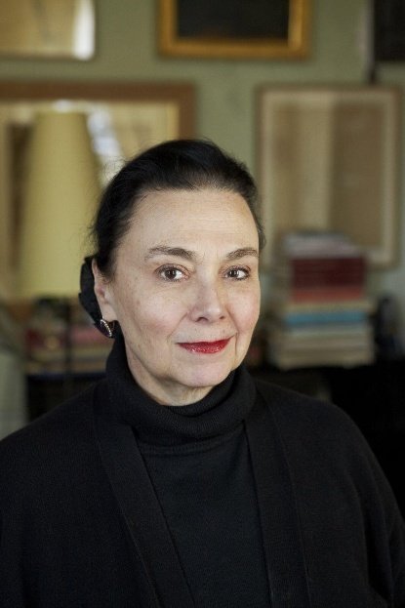

Associate Curator: Sylvie CARLIER, director of collections at the Musée Marmottan Monet

After nineteen years as head of the Musée Paul-Dini in Villefranche-sur-Saône, Sylvie Carlier, chief heritage curator, joined the Musée Marmottan Monet in March 2023, where she directs the collections and the temporary exhibition program.

A specialist in the 19th and early 20th centuries, she has curated around thirty exhibitions and published several major monographic essays: on Gustave Doré (2003, 2012), Antoine Chintreuil (2002), and Henri-Edmond Cross (1998, 2005). She has also worked to restore the place of female avant-garde figures, such as Suzanne Valadon, Jacqueline Marval, Émilie Charmy, and Georgette Agutte, during an exhibition in 2006. Her research also focuses on artistic movements related to Symbolism (2010) and Post-Impressionism (2016).

In autumn 2024, she presented her first exhibition at the Musée Marmottan Monet:
Le Trompe-l’œil, de 1520 à nos jours (October 17, 2024 – March 2, 2025), which was praised for its unprecedented scope and its renewed perspective on this pictorial genre.

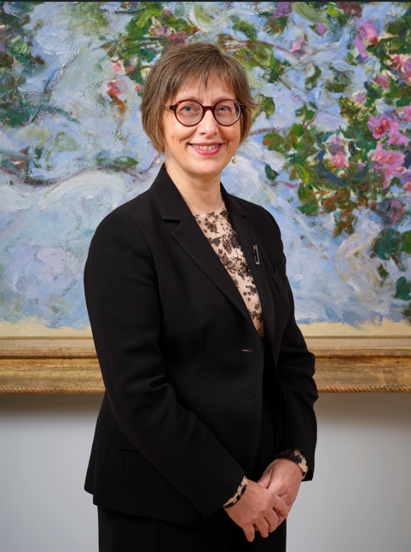

SCENOGRAPHER
Martin Michel

VI – Press visuals

1.  Anonyme  Jeune fille endormie  vers 1615-1620  Huile sur toile  67,5 x 74 cm  Budapest, Szépművészeti Múzeum  / Museum of Fine Art  © Szépművészeti Múzeum/ Museum of Fine Arts, Budapest | 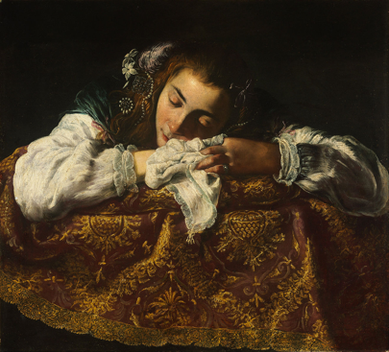
2.  John Everett Millais (1829-1896)  Mon deuxième sermon [My Second Sermon]  1864  Huile sur toile  97 x 72 cm  Londres, Guildhall Art Gallery  © Guildhall Art Gallery, City of London | 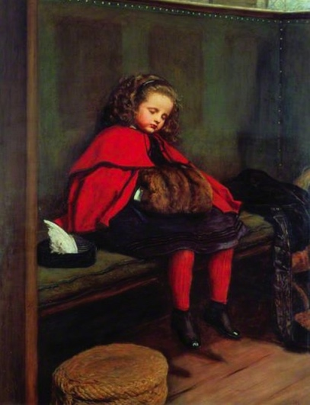
3.  Charles-Émile-Auguste Carolus-Duran (1838-1917)  L’homme endormi  1861  Huile sur toile  87 x 85 cm  Lille, Palais des Beaux-Arts  © GrandPalaisRmn (PBA, Lille) / Philipp Bernard | 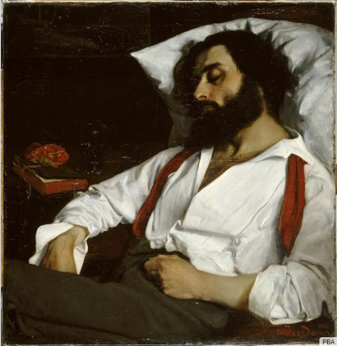
4.  Michael Ancher (1849 1927)  La Sieste [Middagshvil]  1890  Huile sur toile  62 x 79 cm  Skagen, Art Museums of Skagen  © Art Museums of Skagen | 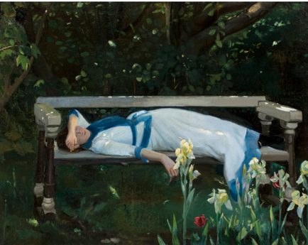
5.  Gabriel von Max (1840-1915)  La Résurrection de la fille de Jaïre  1878  Huile sur toile  123.3 x180.4 cm  Montréal, Musée des beaux-arts © MBAM, Denis Farley | 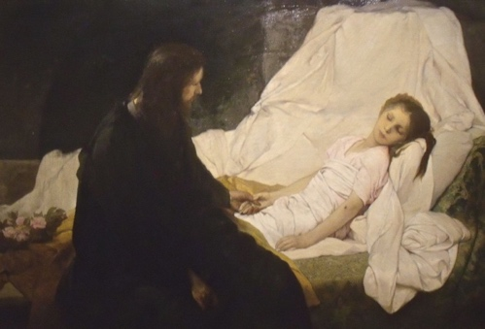
6.  Giuseppe Antonio Petrini (1677 - 1755/1759)  Le Sommeil de saint Pierre (?)  Vers 1740  Huile sur toile  85 x 115 cm  Paris, musée du Louvre – département des Peintures  © Grand Palais Rmn (musée du Louvre) / Stéphane Maréchalle | 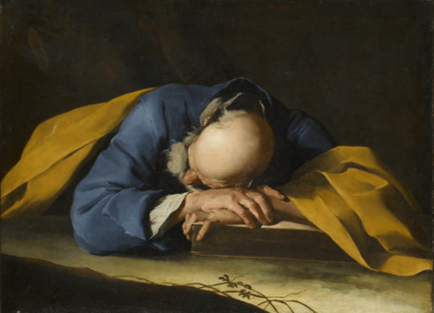
7.  Evelyn De Morgan (1855-1919)  Nuit et Sommeil [Night and Sleep]  1878  Huile sur toile  108,8 x 157,8 cm  Barnsley, De Morgan Foundation  © Trustees of the De Morgan Foundation | 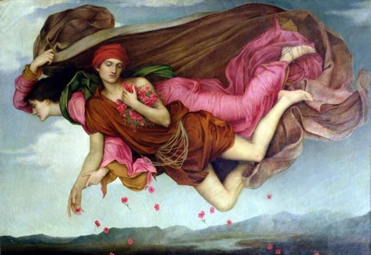
8.  Claude Monet (1840-1926)  Camille sur son lit de mort  1879  Huile sur toile  90 x 68 cm  Paris, musée d’Orsay  © GrandPalaisRmn (musée d'Orsay) / Patrice Schmidt | 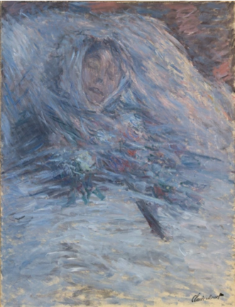
9.  Simon Vouet (1590-1649),  atelier de  Vénus dormant sur des nuages  après 1630  Huile sur toile  100,5 x 84 cm  Budapest, Szépművészeti Múzeum/ Museum of Fine Arts  © Szépművészeti Múzeum/ Museum of Fine Arts, Budapest | 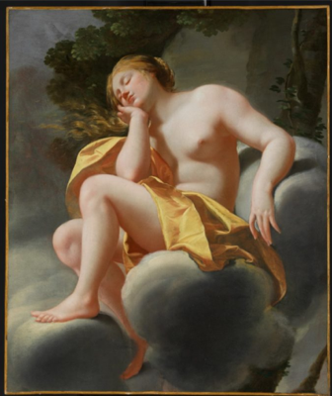
10.  Jean Auguste Dominique Ingres (1780-1867)  Jupiter et Antiope  1851  Huile sur toile  32,5 x 43,5 cm  Paris, musée d’Orsay, dépôt du musée du Louvre - département des Peintures  © GrandPalaisRmn (musée d'Orsay) / Franck Raux | 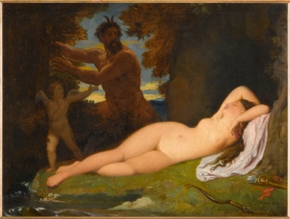
11.
Félix Vallotton (1865-1925)
Femme nue assise dans un fauteuil
1897
Huile sur carton marouflé sur contre-plaqué
28 x 27,5 cm
Grenoble, musée de Grenoble
© Musée de Grenoble - J.L Lacroix
12.  George Frederic Watts (1817-1904)  Endymion  1903 - 1904  Huile sur toile  104, 1 x 121,9 cm  Compton, Surrey, Watts Gallery  © Watts Gallery Trust | 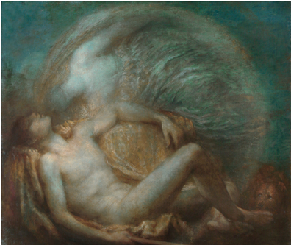
13.
John Faed (1819-1902)
Le Rêve du poète
1881 – 1882
Huile sur toile
104,7 x 142,9 cm
Edimbourg, Royal Scottish Academy of Art & Architecture Collections (RSA)
© RSA Collections, Edinburgh
14.  Francisco José de Goya y Lucientes (1746-1828)  Le sommeil [El sueno]  1790  Huile sur toile  46,5 × 76 cm  Dublin, National Gallery of Ireland  © National Gallery of Ireland | 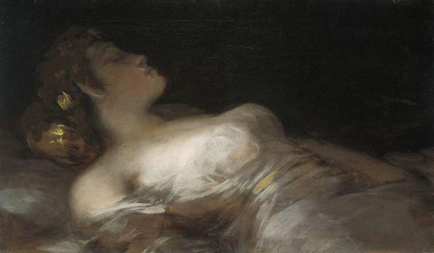
15.  Johann Heinrich Füssli (1741-1825)  L'Incube s'envolant, laissant deux jeunes femmes  1780  Huile sur toile  86,4 x 110,5 cm  Paris, collection Farida et Henri Seydoux  © Collection Farida et Henri Seydoux, Paris | 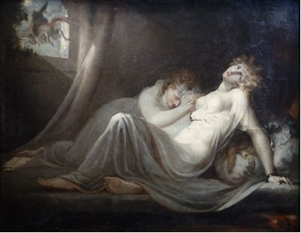
16.
Maximilián Pirner (1854-1924)
La Somnambule [Naměsična]
1878
Huile sur toile
157 × 87 cm
Prague, Národní galerie / National Gallery
© Photo National Gallery Prague 2025
17.  Gabriel von Max (1840-1915)  Juliette Capulet le matin de son mariage  1874  Huile sur toile  41,9 x 51 cm  Graz, Neue Galerie, Universalmuseum Joanneum  © Lackner/UMJ Graz | 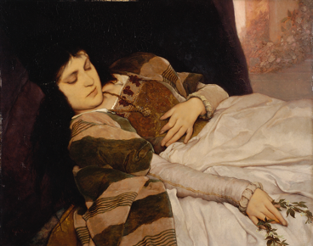
18.  Eugène Delacroix (1798-1863)  Le lit défait  Vers 1824  Graphite et aquarelle sur papier  18,3 x 29,8 cm  Paris, musée national  Eugene-Delacroix  © GrandPalaisRmn (musée d'Orsay) / Rachel Prat | 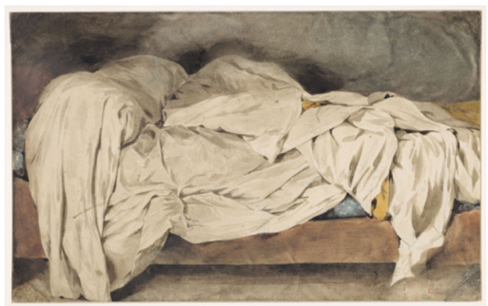
19.
Federico Zandomeneghi (1841-1917)
Jeune fille endormie dit aussi Intérieur avec figure féminine endormie [Fanciulla dormiente (interno con figura femminile che dorme)
1878
Huile sur toile
60 x 74 cm
Florence, Gallerie degli Uffizi,
Palazzo Pitti
© Gabinetto Fotografico delle Gallerie degli Uffizi
20.  Joaquin Sorolla y Bastida (1863-1923)  Mère (Madre),  Vers 1900  Huile sur toile  125 x 169 cm  Madrid, Museo Sorolla  © Museo Sorolla, Madrid | 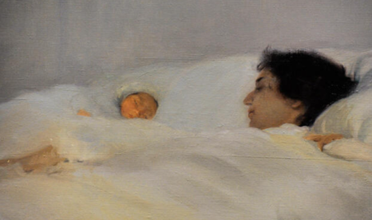
VII - 2026 Program

GIOVANNI SEGANTINI (1858-1899)
Je veux voir mes montagnes (I want to see my mountains)
From April 29 to August 16, 2026

Co-curators:

Gabriella Belli, art historian and museologist
Diana Segantini, independent curator and specialist in the work of Giovanni Segantini
From April 29 to August 16, 2026, the Musée Marmottan Monet will present the first Parisian monographic exhibition on Giovanni Segantini, a major figure of European Symbolism and Divisionism. Bringing together around sixty works—paintings, pastels, and drawings—it traces the dazzling journey of an artist who made alpine landscapes the heart of an aesthetic and spiritual quest. From Italian Lombardy to the Swiss Engadine valley, Segantini knew how to capture the power of nature and reveal its symbolic dimension, far beyond realism.
He dreamed of exhibiting in Paris for the Universal Exhibition of 1900, a project interrupted by his premature death in 1899. More than a century later, this exhibition, curated by Gabriella Belli and Diana Segantini, finally pays tribute to his visionary eye and his unique way of putting man and nature in dialogue, with astonishing modernity.

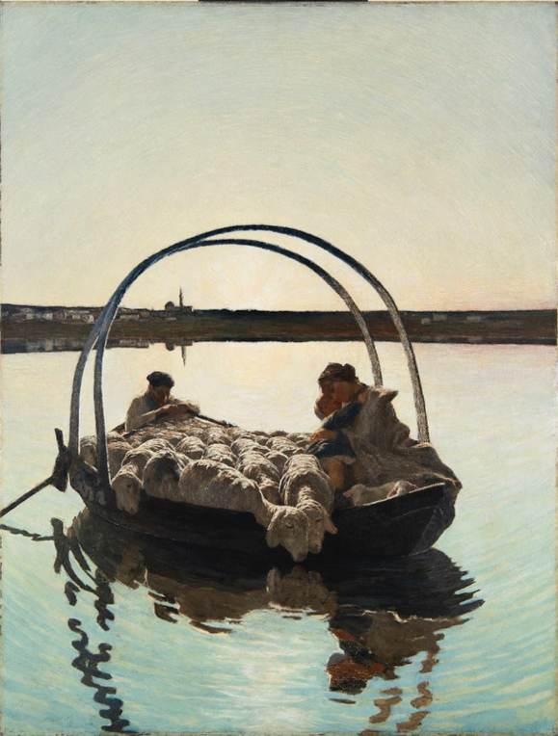

Giovanni Segantini, Ave Maria a trasbordo, 1886, huile sur toile
120 x 93 cm, musée Segantini, Saint-Moritz, Suisse ©Stephan Schenk, Segantini Museum

LES DIALOGUES INATTENDUS – OPUS 10 (The Unexpected Dialogues – Opus 10)
Monet / Sécheret
Paysages d’eau (Water landscapes)
From October 9, 2025, to February 15, 2026

Curator : Benjamin Olivennes, author and professor of philosophy

Jean-Baptiste Sécheret (born in 1957) is the tenth artist invited by the Musée Marmottan Monet to design an exhibition in dialogue with the works in the collection. A painter, he works in series and on the motif, painting the landscapes on which his gaze falls—monuments, buildings, factories, houses—before continuing his works in the studio.
For the Musée Marmottan Monet, he will present a set of paintings featuring the coastal landscapes and skies of Trouville, the famous Hôtel des Roches Noires which was one of the views from his apartment when he lived in that city. As for Monet, the Normandy landscapes are familiar spaces for Sécheret and will lead to a meeting with two paintings by the master of the house: Sur la plage de Trouville (1870) and Camille sur la plage (1870).
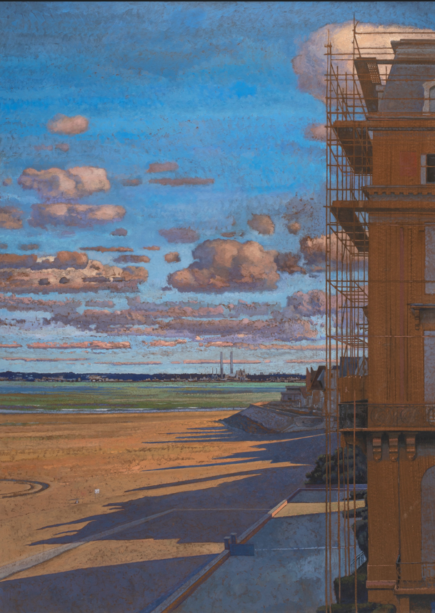

Jean-Baptiste Sécheret, Les Échafaudages. Hommage à Léon Spilliaert, 2007-2024
Pigments et colle sur papier marouflé sur toile, 161 x 132 cm © Bertrand Huet

VIII – Practical Information

Address
2, rue Louis-Boilly
75016 Paris

Website
www.marmottan.fr

Access
Métro: La Muette – Ligne 9
RER: Boulainvilliers – Ligne C
Bus: 32, 63, 22, 52, 70, P.C.1

Days and hours of operation
Open Tuesday to Sunday from 10 a.m. to 6 p.m.
Late opening on Thursday until 9 p.m.
Closed on Mondays, December 25, January 1, and May 1

Prices
Full price: €14
Reduced price: €9
Under 7 years old: free

Group reservations
Tel. 01 44 96 50 83
reservation@marmottan.com

Educational workshop reservations
atelier@marmottan.com

Audioguide
Available in French and English: €4

Shop
Open during museum days and hours
boutique@marmottan.com

